**Supplier Quality Analysis - Manufacturing Sector**

GOKULNATH K & E24755

**Overview**

Supplier quality analysis in the manufacturing sector is essential to ensure the materials and components from suppliers meet required standards, as poor quality can lead to production delays, increased costs, and product defects. A data analyst focuses on metrics such as defect rate, on-time delivery, supplier lead time, cost of poor quality, and supplier responsiveness. These metrics help identify performance trends and areas for improvement in the supply chain. Analyzing this data aids in reducing waste, improving production efficiency, and maintaining product reliability. Ultimately, supplier quality analysis ensures operational continuity and customer satisfaction.

**Objective**

1. **Ensure Material and Component Quality:** Guarantee that all materials supplied meet product specifications and quality standards.
2. **Reduce Defect Rates:** Minimize the percentage of defective parts received from suppliers to improve production efficiency.
3. **Improve Supplier Performance:** Enhance supplier reliability through better lead times, on-time delivery, and responsiveness to quality issues.
4. **Lower Cost of Poor Quality (COPQ):** Reduce costs related to rework, scrap, and defective materials from suppliers.
5. **Support Continuous Improvement:** Drive supplier quality improvements through data-driven insights, feedback, and corrective actions.
6. **Mitigate Supply Chain Risks:** Identify and address potential risks in the supply chain caused by poor supplier quality to avoid disruptions.
7. **Ensure Compliance and Standards:** Ensure suppliers comply with industry regulations and company-specific quality requirements.

**Assigned Task(s)**

* Supplier Quality Analysis - Manufacturing Sector

**Task Details**

* **Task 24 :** Supplier quality analysis ensures suppliers meet required standards in manufacturing. A data analyst tracks defect rates, delivery times, and performance metrics to improve supplier reliability, reduce costs, and maintain production efficiency.
* **Status:** Completed.
* **Details:**

1. The code uses pandas for data manipulation, numpy for calculations, and matplotlib.pyplot for visualizations.
2. **Loading the Dataset**:

* Supplier quality data is loaded from a CSV file, and the first few rows are displayed to understand the data structure.

1. **Data Cleaning**:

* Rows with missing values are removed to ensure accurate analysis.

1. **Rate Conversion**:

* Defect Rate (%) and On-Time Delivery (%) are converted to decimals for easier calculations.

1. **Performance Score Calculation**:

* A performance score is calculated using: Performance Score=(On-Time Delivery×10)−(Defect Rate×10)

1. **Supplier Classification**:

* Suppliers are categorized as 'Excellent', 'Average', or 'Poor' based on their performance scores.

1. **Identifying Poor Performers**:

* Suppliers categorized as "Poor" are extracted for further analysis.

1. **Visualizations**:

* **Bar Chart**: Displays performance scores with an average threshold line.
* **Scatter Plot**: Shows the relationship between defect rates and on-time delivery percentages, highlighting performance thresholds.

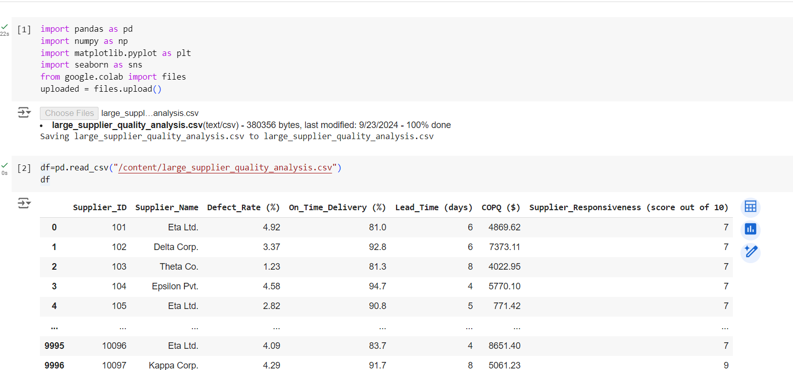

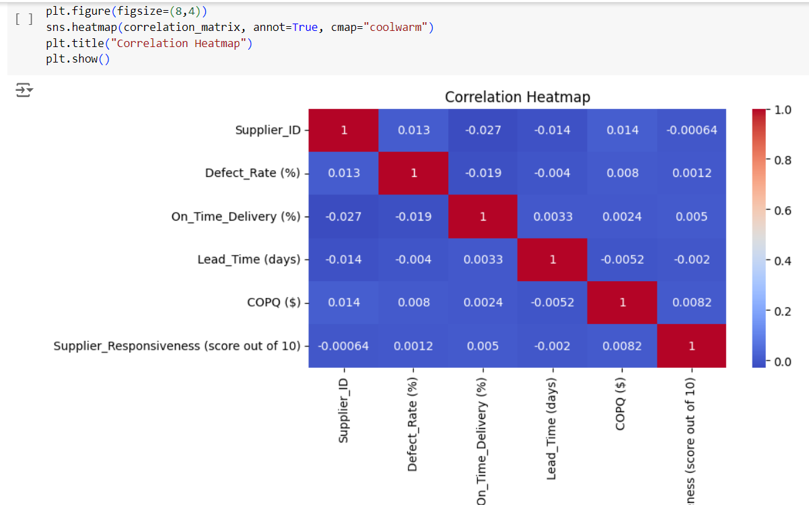

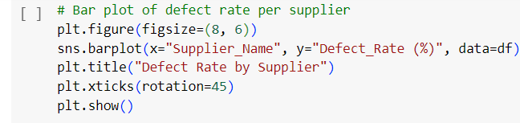

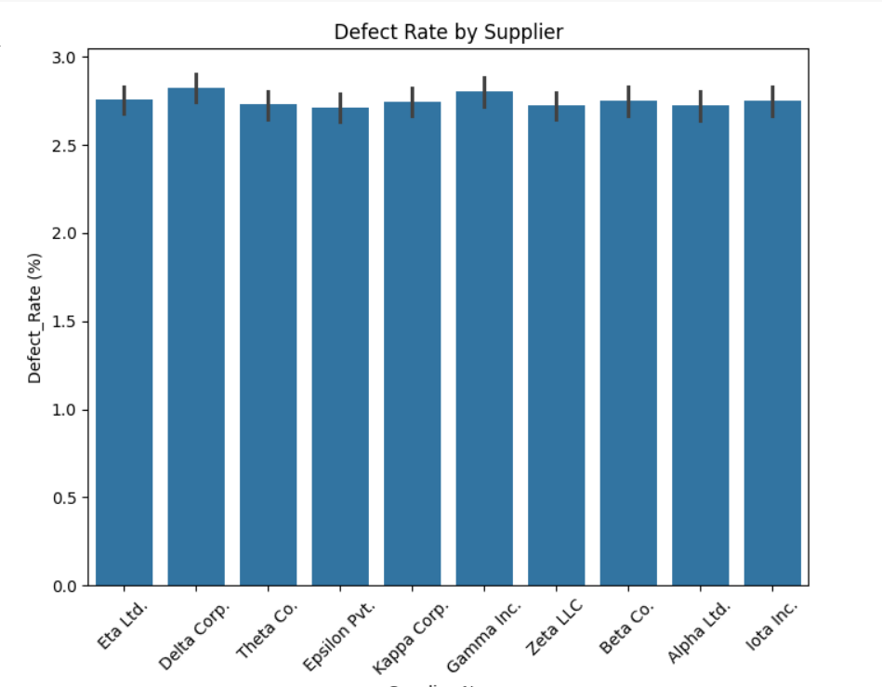

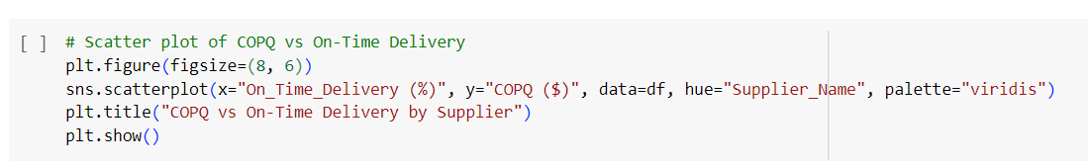

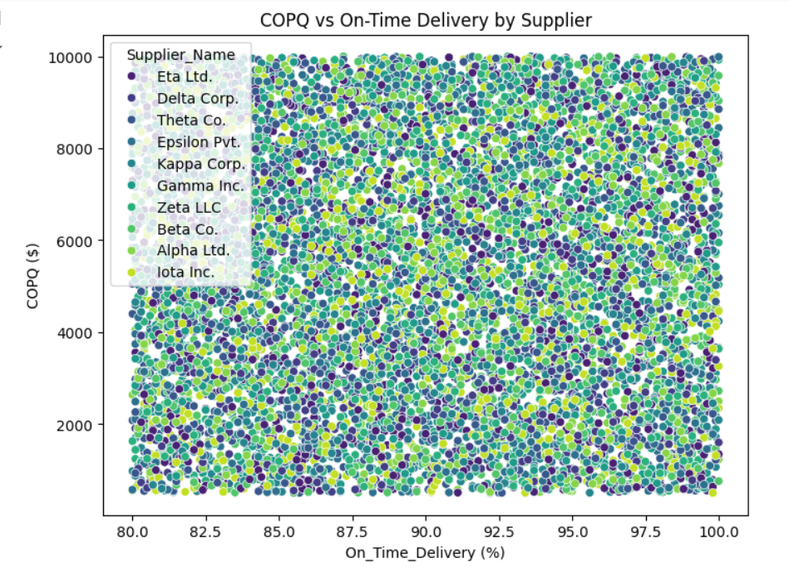

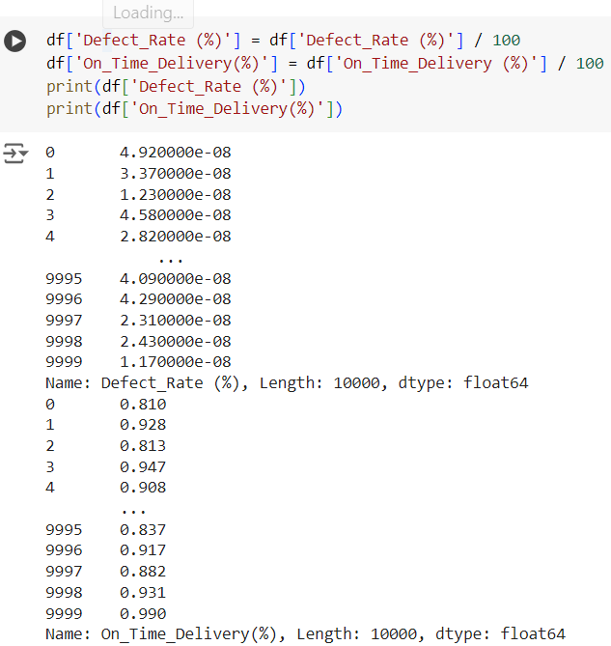

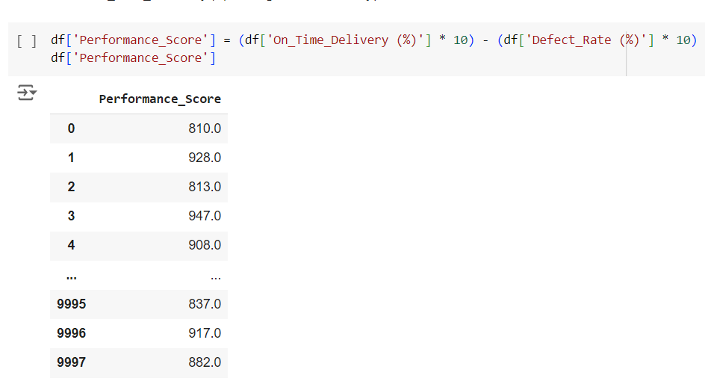

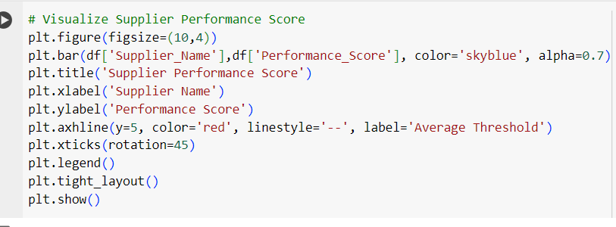

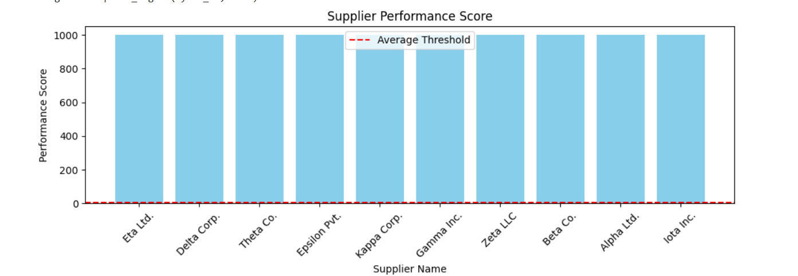

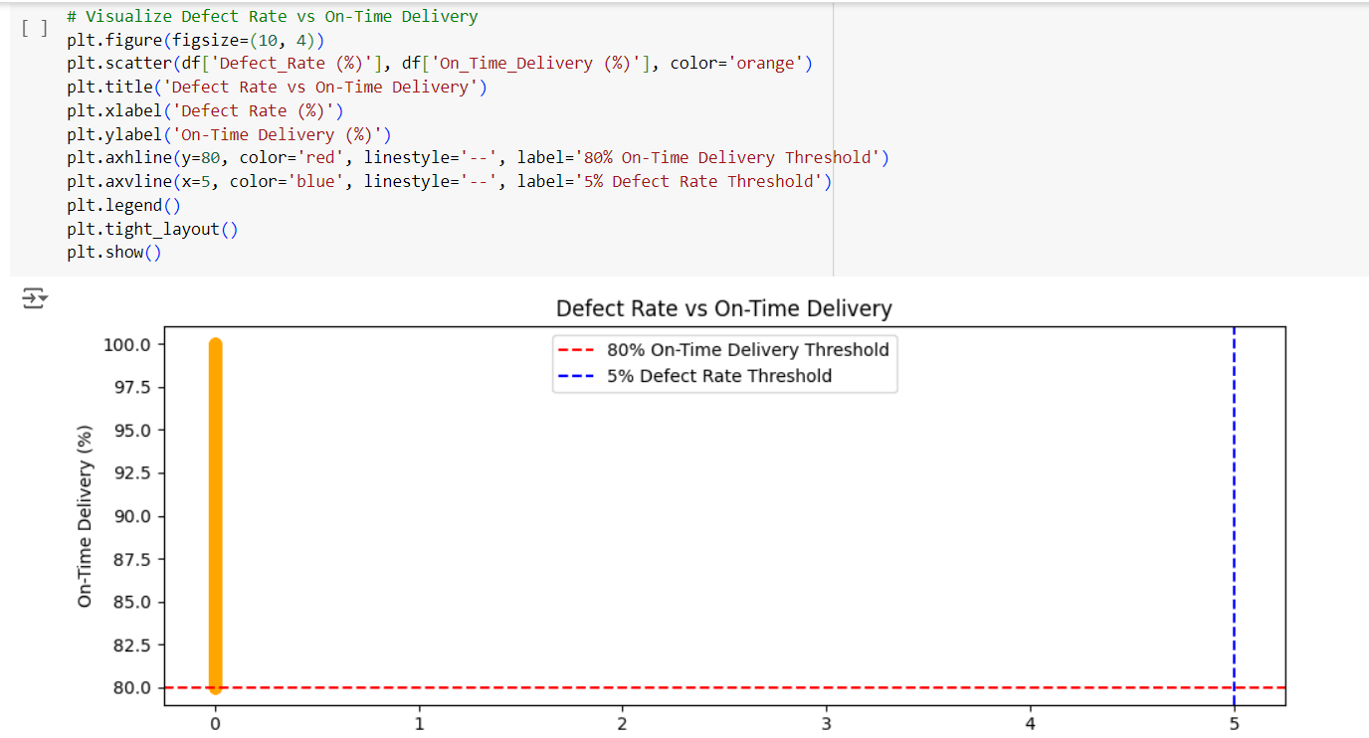

**Progress**

* **Accomplishments:**

1. **Data Acquisition:** Successfully collected and consolidated supplier quality data from multiple sources into a comprehensive dataset.
2. **Data Cleaning:** Implemented data cleaning processes to remove missing or inconsistent entries, ensuring the accuracy of the analysis.
3. **Performance Metric Development:** Developed a performance score metric that integrates defect rates and on-time delivery, providing a holistic view of supplier quality.
4. **Supplier Classification:** Categorized suppliers into 'Excellent', 'Average', and 'Poor' based on their performance scores, enabling targeted interventions.
5. **Visualization Creation:** Created clear visualizations, including bar charts and scatter plots, to effectively communicate supplier performance insights to stakeholders.
6. **Identification of Poor Performers:** Identified and summarized suppliers with poor performance, facilitating focused quality improvement initiatives.
7. **Actionable Insights:** Generated actionable insights to enhance supplier relationships and improve overall operational efficiency in the manufacturing process.
8. **Strategic Decision Support:** Provided valuable data-driven insights to support strategic decision-making in supply chain management.

* **Metrics:**

1. **Defect Rate:** Measures the percentage of defective products received from suppliers, indicating quality issues.
2. **On-Time Delivery Performance:** Evaluates the percentage of orders delivered on time, reflecting supplier reliability.
3. **Lead Time Variability:** Assesses the consistency of supplier lead times; variability can indicate issues in supply chain management.
4. **Cost of Poor Quality (COPQ):** Measures the costs associated with defects and failures, including rework and returns.
5. **Supplier Corrective Action Request (SCAR) Rate:** Tracks the frequency of corrective actions requested from suppliers due to quality issues.
6. **Supplier Responsiveness:** Evaluates how quickly suppliers respond to inquiries and issues, which impacts overall supplier performance.
7. **Customer Complaints:** Monitors the number of complaints related to supplier products, providing direct insight into quality perception.

**Challenges and Solutions**

* **Challenges Faced:**

1. Data from different suppliers may be incomplete or inconsistent, affecting the accuracy of the analysis.
2. Lack of clear communication channels can lead to delays in addressing quality issues.
3. High variability in defect rates can make it difficult to pinpoint root causes of quality issues.
4. Slow response from suppliers to quality issues can disrupt production.
5. Unpredictable lead times from suppliers can affect production schedules and increase costs.

* **Solutions Implemented:**

1. Standardize data collection processes and perform regular data cleaning to ensure uniformity.
2. Establish clear and efficient communication protocols with suppliers for timely updates and corrective actions.
3. Implement real-time defect monitoring systems to quickly identify and resolve quality deviations.
4. Set performance benchmarks and include supplier responsiveness in contract agreements, ensuring timely resolution of issues.
5. Collaborate with suppliers to streamline logistics and establish more accurate lead time forecasts.

**Next Steps**

* **Upcoming Tasks:** To effectively face upcoming tasks, prioritize clear goals, break them into manageable steps, and maintain consistent communication with stakeholders.
* **Goals:** Break down the goals into actionable steps, prioritize tasks, and stay adaptable while tracking progress regularly.

**Conclusion**

* **Summary:** Supplier quality analysis ensures that sourced materials meet required standards, improving product quality and reducing costs associated with defects. It involves continuous monitoring and collaboration with suppliers to maintain consistent performance.
* **Acknowledgments:** Thank you all for your time and attention, I truly appreciate your presence and engagement today.